Body Buck with stilts for FFR Roadster

To add stilts:

Per the following pics:
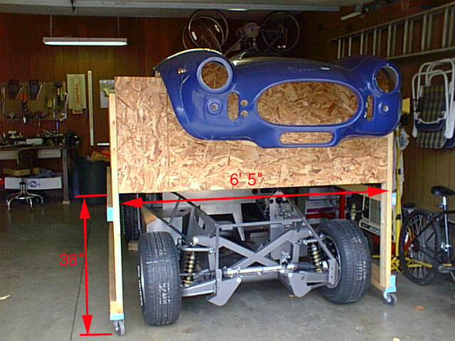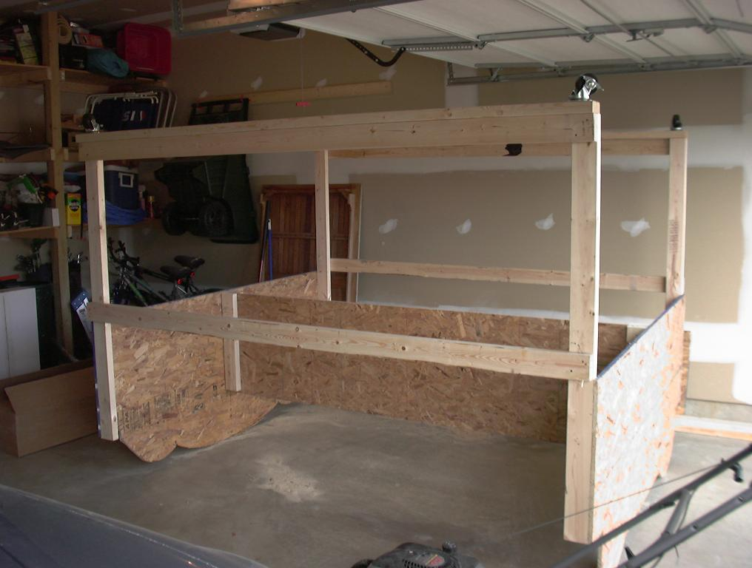

Center section is 8’ long. By doing this you can use 8’ 2x4’s. The center section 4’x8’ OSB cut in half also makes for a nice shelf. The vertical legs are made from 10’ 2x4’s cut in half. Otherwise everything is 8’ 2x4’s. I also used 70mm casters with two of them being locking types. In retrospect I probably should have gotten at least two that don’t swivel. The combination of the 5’ legs matched to the 24” vertical spacing on the diagram actually comes out to 36”. When you factor in the extra 2x4 at the bottom and the castor height you gain another 4-5 inches. The shelf helps with some of the racking that can happen if you push from one side but you still need to be careful. Foam pipe insulation goes along the top where the body meets. It’s a good idea to duct tape this down so it won’t shift or fall off.

Parts list:
3 sheets of OSB 8’x4’. (I used 5/8” thick and it almost seems too thick)
qty:9 8’ 2x4
qty:2 10’ 2x4
4 casters
1 package of 4 pieces of foam tubing insulation.
Duct tape
Nails and long screws for the casters

Credits:
Huge thanks to Wade Chamberlain for putting together the CAD portion of this. http://www.quickkeys.com/Cobra/Default.htm

Thanks to John Baker for taking some detailed pics and the measurement for the stilts. http://members.wilkshire.net/jabaker/jbcobra/

Stilt info by Scott Brooke. You should always be able to find this file at my web site as well as more pics of my buck. http://www.thebrookes.com/scott/cobra

Please direct comments or corrections to me at sbrookeinmd@yahoo.com.

